Hi Sir  ,

User number USER35 .

PROGRAM-ID. TESTCODE.

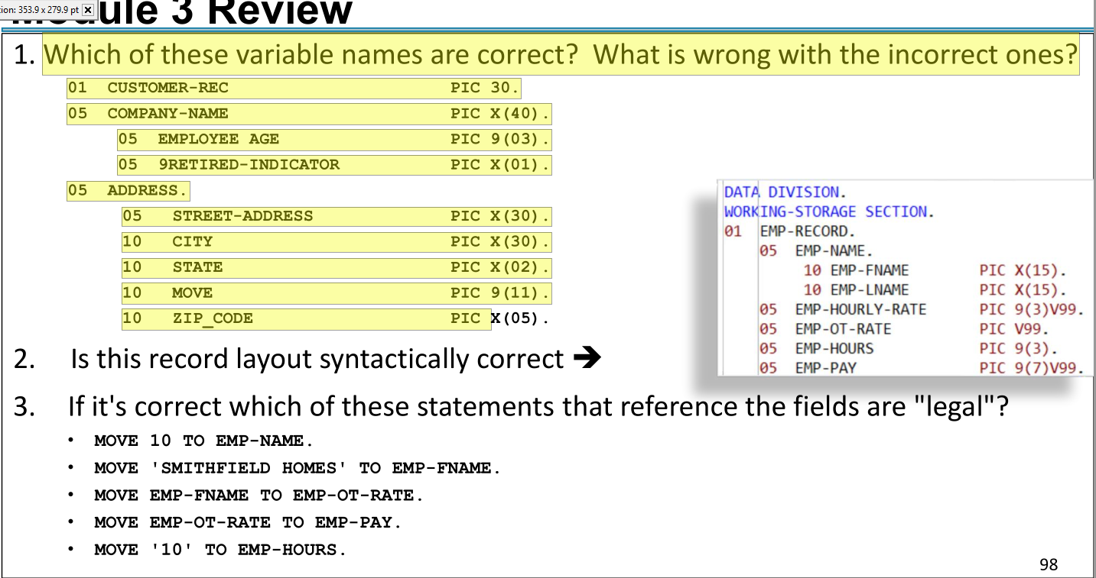

Answer :

The whole record need to be restructured.

      *  group item "CUSTOMER-REC" contained the "PICTURE" clause.    (error / Group Item must not having a picture clause  (also end by dot)

       01  CUSTOMER-REC.                                                00001500

           05 COMPANY-NAME          PIC X(40).                          00001600

      * *   adding Underscore ( spaces is not accepted in var name )    00001700

           05 EMPLOYEE_AGE PIC 9(03).                                   00001800

           05 9RETIRED-INDICATOR PIC X(01).                             00001900

      * // ADDRESS  is  not allowed as elementary item/group item    reserved word!!    00002000

           05 ADDRESS1.                                                 00002100

               10 STREET-ADDRESS PIC X(30).                             00002200

               10 CITY PIC X(30).                                       00002300

               10 STATE PIC X(02).                                      00002400

      *    // Move is not allowed as var name    it is an op/code      00002500

           10 MOVE1 PIC 9(11).                                          00002600

           10 ZIP_CODE PIC X(05).                                       00002700

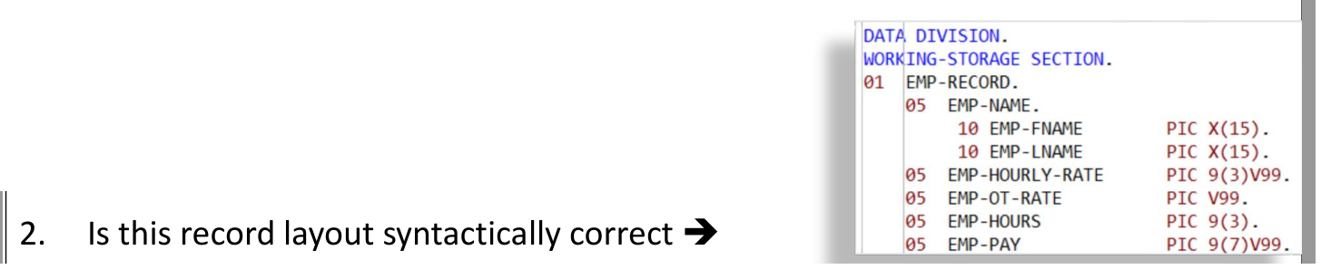

Answer :Yes . As per PROGRAM-ID. TESTCODE

 yes

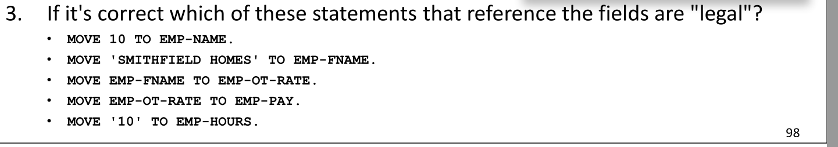

**move 10 to EMP-Name . (10 will be left justified to fall in EMP-FName not legal because 10 is not a name )**

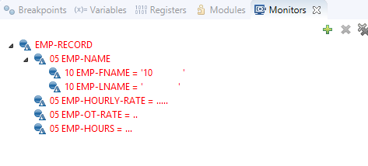

**MOVE 'SMITHFIELD HOMES' TO EMP-Name.**

**(not legal because the EMP-fname is having the first name and emp_lname is just having the letter “s”)**

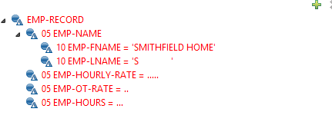

**MOVE 'SMITHFIELD HOMES' TO EMP-FNAME.**

**(not legal because of the truncation due to putting 16 byte in EMP-FNAME which is 15 byte alphanumeric dataitem )**

**MOVE EMP-FNAME TO EMP-OT-RATE.**

**(not legal because of moving chars/ alphnumeric to a numeric field / the numeric field is now zeros )**

**MOVE EMP-OT-RATE TO EMP-PAY.**

**(Ok will work because of same decimal partition )**

**MOVE '10' TO EMP-HOURS.**

**(Caution will work but it is better to write the 10 without qutation)**

**GOBACK.**

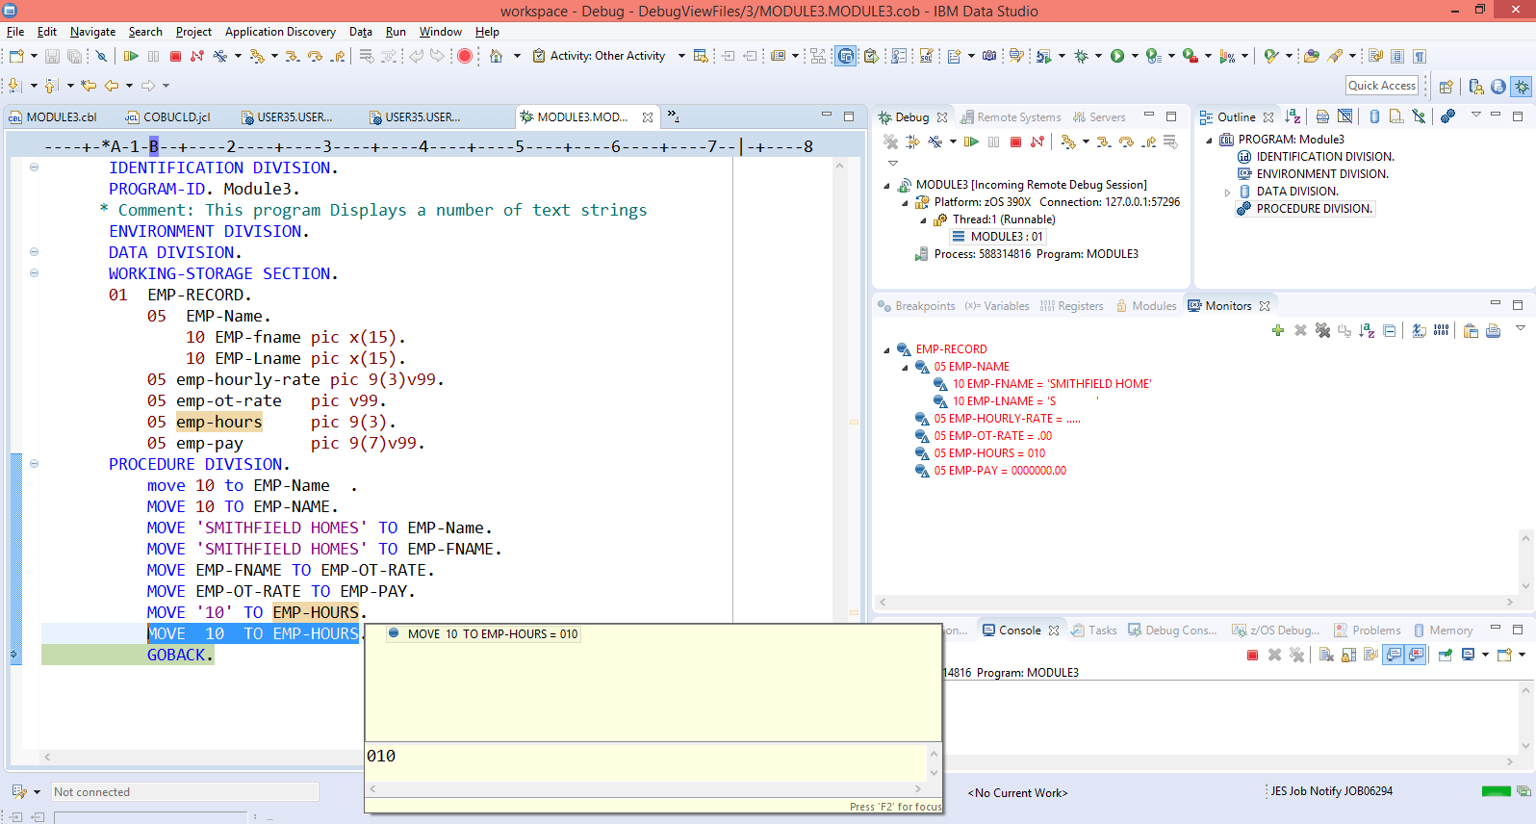

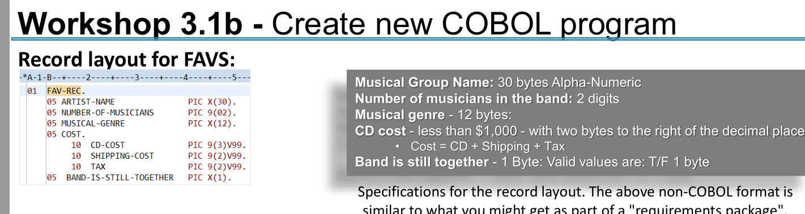Answer : done as below

